Name : Saurabh Jadhav

Topic : VPC with public and private subnetting.

Assignment no. : 17

1. Navigate to VPC and click on create VPC

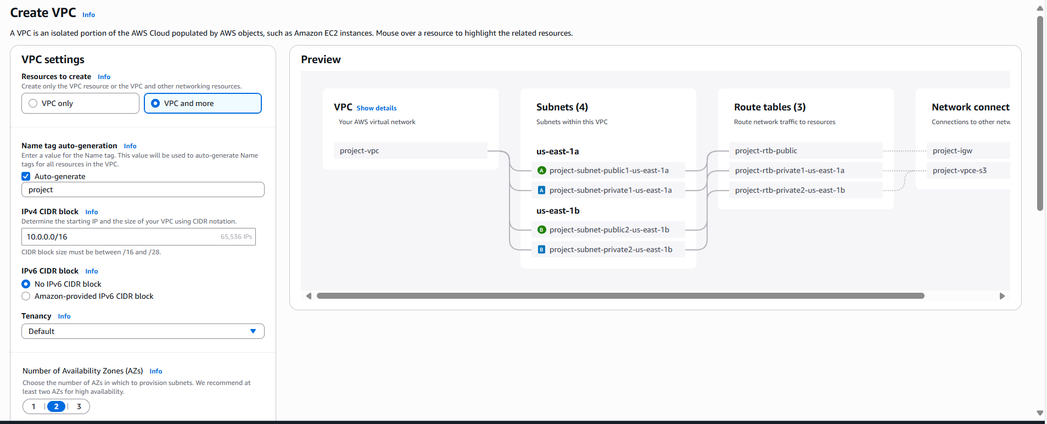

1. Provide details such as name of VPC and IPv4 CIDR, else keep everything as default.

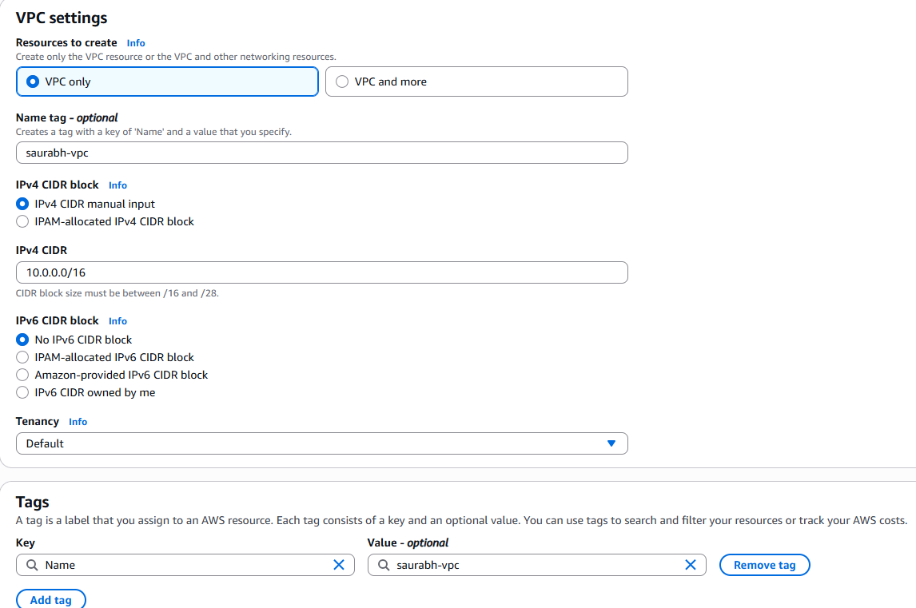

1. Create 5 subnets for VPC.
2. Subnet1 : public-subnet, CIDR : 10.0.1.0/24, select same AZ for all subnet.

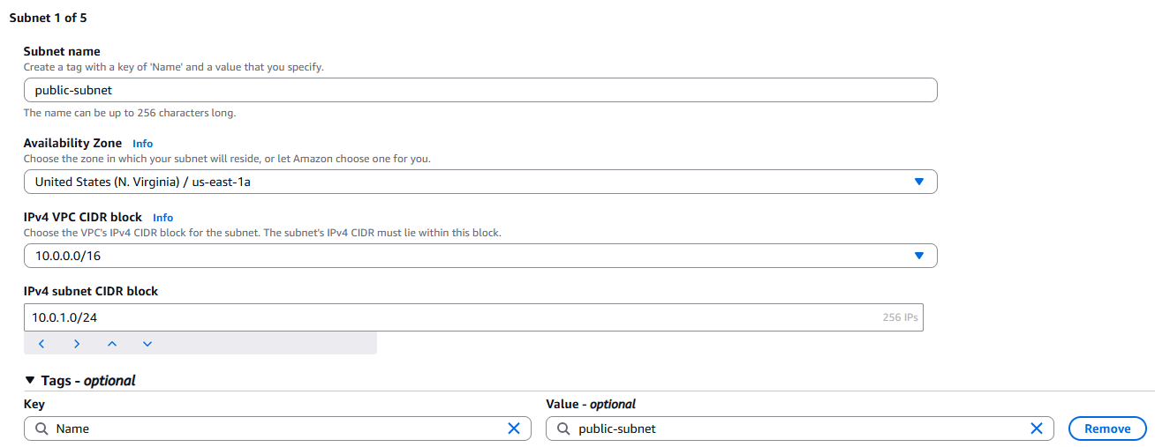

1. Subnet2 : private-subnet-1, CIDR: 10.0.2.0/24
2. Subnet3 : private-subnet-2, CIDR: 10.0.3.0/24
3. Subnet4 : private-subnet-3, CIDR: 10.0.4.0/24
4. Subnet5 : private-subnet-4, CIDR: 10.0.5.0/24

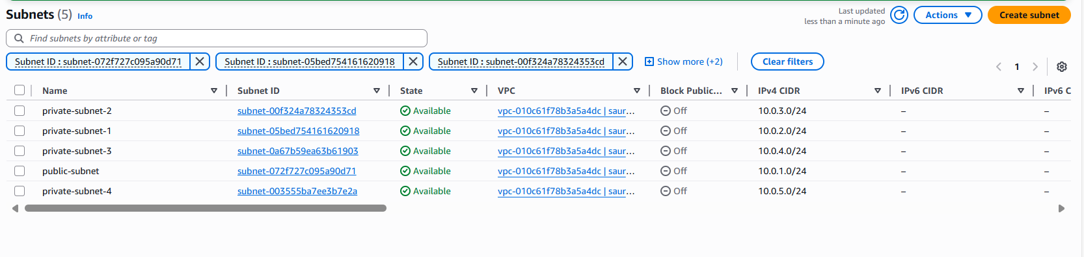

1. Create internet gateway

Attach Internet gateway to VPC.

1. Create route table for Saurabh-vpc.

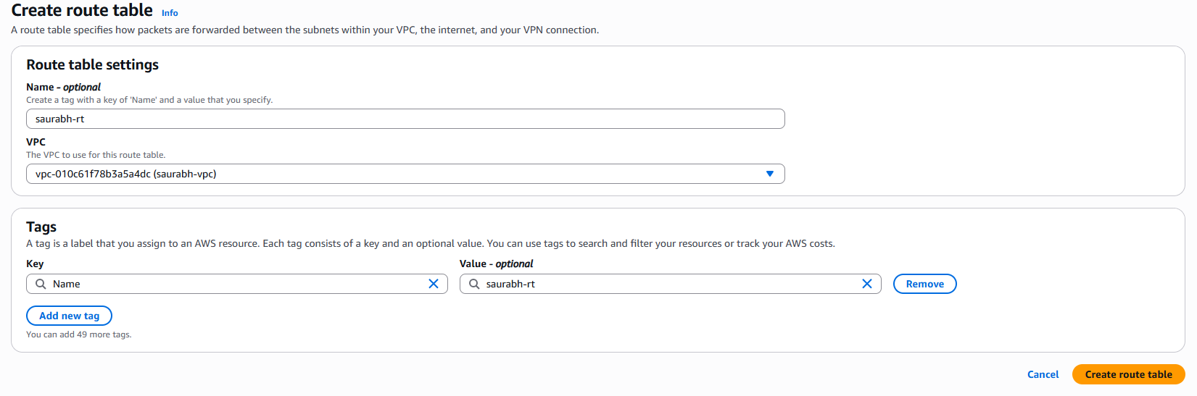

Provide the subnet needs to be associated with route table.

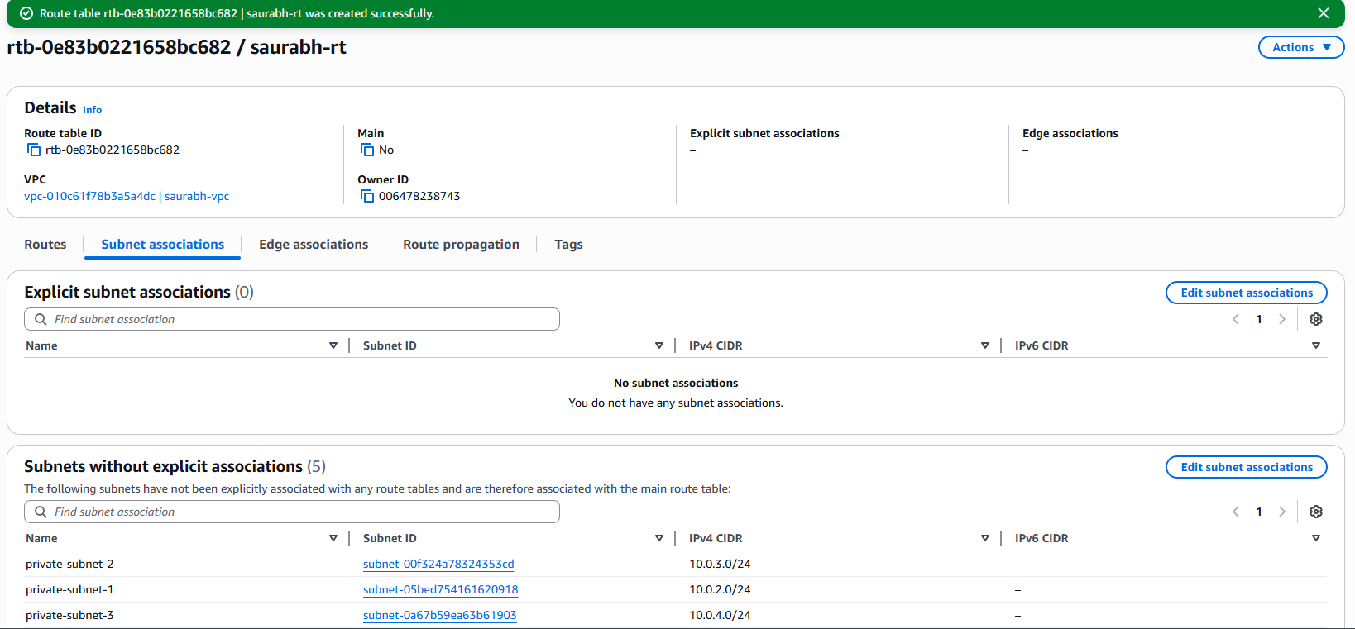

Add route to the route table.

Add route to internet gateway.

1. Create two EC2 instances one in public subnet and other in private subnet.
2. Create instance in public subnet. We are able to connect to it and install httpd package from internet.

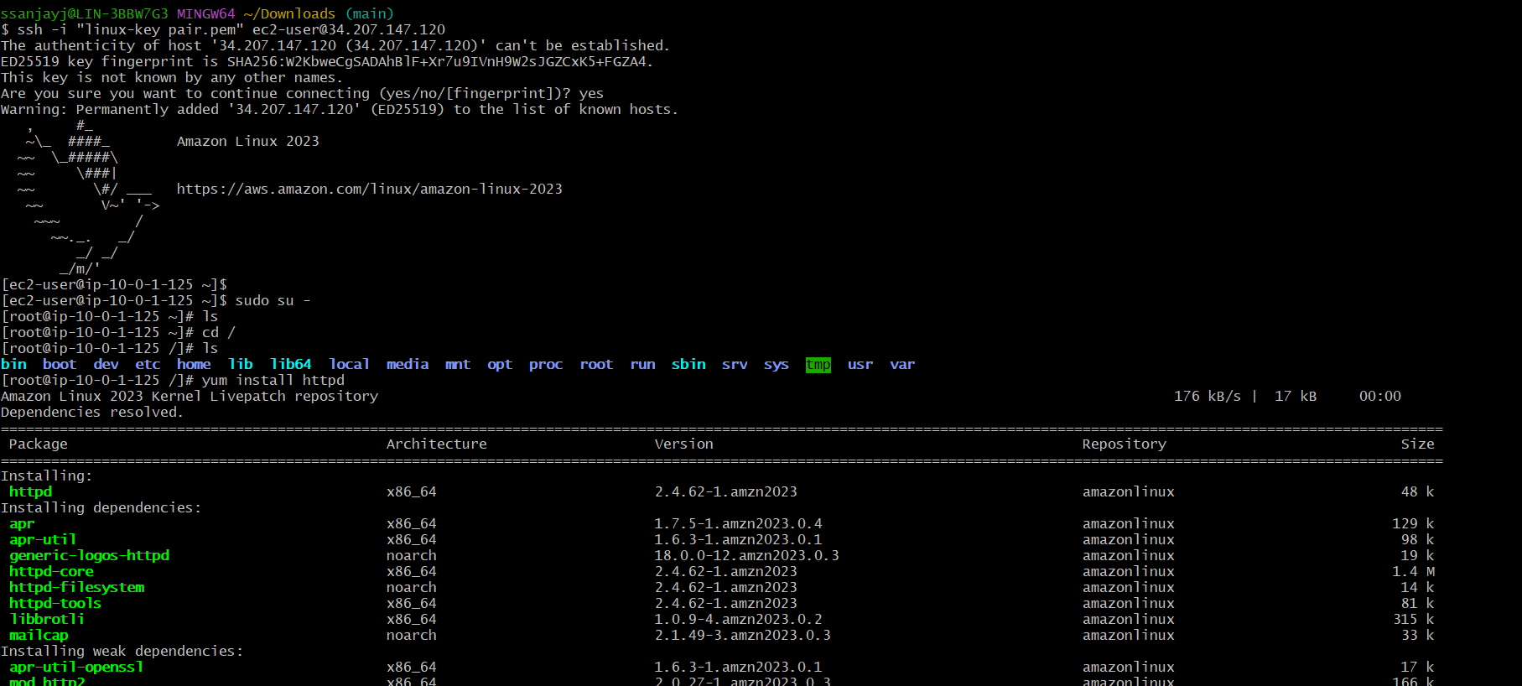

1. Created another instance in private subnet. We are unable to connect to it.

